Basics of an Instagram-like app involves:

**1. Authorization**

* creating a new account
* signing in into the existing account via social networks (there is an option to develop login via e-mail, but we do not recommend implementing this feature in the first app version since it is rather time-consuming)

**2. Editing profile**

* adding personal data
* editing personal data
* removing personal data

**3. Post creation**

* uploading pictures taken in the app or existing images from the gallery
* mentioning people, adding tags

**4. Feed**

* subscribing (one-way following)
* liking
* commenting

**5. Social features**

* sharing
* inviting friends from Facebook (not necessary)

**6. Image customization**  
Standard options like:

* cropping
* rotating
* image adjustments
* applying filters

**7. Geolocation features**

* determining the geolocation of the existing image
* determining current geolocation and adding it to the post

**8. Messaging**

* text and photo messaging

**9. Notifications**

* push notifications

**10. Search**

* by username or full name
* by tags
* by post description

Blue – not necessary (can code if time permits) Till pages 6

Yellow – Features of my app

**KPIs to Follow for an App Like Instagram**

You will need to measure the performance of your app; therefore, its Key Performance Indicators should be considered when developing your product.

**1. Users**  
The first indicator to pay attention to is the number of active users. You can grow the audience engaged in your app, with the help of social media marketing, invitations to top users, and referral programs.

Regarding social media marketing, it is advisable to start your campaign at least half a year before the intended product launch date. It is a good idea to create pages for your app on social networks to reach out to your target audience. Rewarding users with features when they invite their friends to use your app is a thoughtful step that can quickly increase the overall number of users.

Like any application, social platform has its influencers, you can invite relevant celebrities to your app by giving them unlimited access and possibilities to promote themselves. In return, numerous fans of the influencer will join the app to keep in touch with updates from their favorite celebrity.

**2. Engagement**  
The quantity of users who sign up for your app does not determine success on its own. There are other significant factors like the average amount of time people spend in the app, frequency of daily logins, number of files they upload, and likes they leave. All these indicators show how dedicated the users are and how likely they are to continue using the app.

**3. Retention**  
You should remind users about your app occasionally, when it is convenient for them. Push notifications serve this purpose. However, before sending any, you should study your audience and schedule your pushes when the users are more likely to be available and willing to spend some time in the app. There are other ways to keep them in the application like organizing various competitions for the best-themed pictures, quizzes, and giveaways.

These are the common types of social media to know about:

* **Social network apps**

They are used to connect and interact with other people online. These social networking apps can be used for personal needs (Facebook, Twitter) or for professional communication (LinkedIn).

* **Media sharing networks**

Such social apps allow users to share all kinds of media files (photos, videos, GIF files, etc.). The most famous representatives of this type are Instagram, Snapchat, YouTube, Vimeo, and Imgur.

* **Networks for consumer reviews**

Such social media apps are used by customers to find and review businesses they’ve had experience with. Yelp is probably one of the most prominent examples in this category.

* **Community and discussion forums**

These platforms are great places for asking questions and receiving answers, sharing news, ideas, insights, and experience. The best social media apps in this category are Quora and Reddit, of course.

* **Bookmarking and content curation networks**

Users of these apps can share their own content and discover the content of other users and save it. Such apps like Pinterest, Mix, and Flipboard belong to this type of social media.

* **Blogging and publishing platforms**

These social media platforms allow users to create their own blogs and publish their content there. Tumblr and Medium are extremely popular now and thousands of people make their posts go live there every day.

* **Interest-based networks**

This type of social networking unites people with common interests. Users can share their hobbies and related experiences on such platforms. Goodreads or Last.fm are nice examples to check out.

* **Anonymous social networks**

This type of social networks is especially loved by teens because it lets them communicate anonymously with each other. Some of the most used apps of this category are Whisper, Ask.fm, and After School.

As you can see, there are many types of social media apps. You should pay attention to these categories because each of them defines the key features of the apps that belong there. Once you decide on your direction, make sure you have analyzed it properly and reviewed your potential competitors.

The next step to take is to review the latest social media trends.

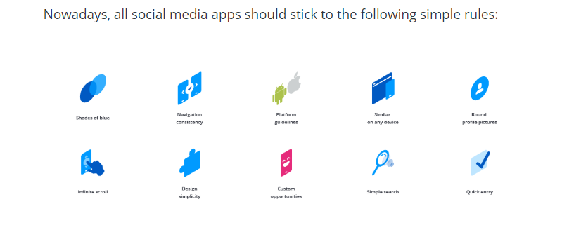

* Use the shades of blue as this color is not considered annoying.
* Use the same navigation bar with search functions, notifications, and profile icon throughout the app on every screen where they are required.
* The design of the entire application should be adapted to a specific platform (there are design guidelines for iOS and Android) for users to feel comfortable using the app on their device. At the same time your app design should have its key features in common on all platforms. It is necessary to ensure equal user experience and feel if a user changes iOS to Android or vice versa.
* Smooth switch from a web app design to a mobile app design to make user experience similar on any device
* Round profile pictures help to focus on a user’s face and make it simpler to remember them or distinguish them from the list of others
* Infinite scroll of posts
* Design simplicity and focus on user content
* Possibility of self-expression in design (custom opportunities like changing a profile picture, cover image, or even profile colors)
* Simple search of users and relevant content
* Quick sign in or app entry without signing up on the first stages to give an opportunity for users to find out more about your product

### Basic Features All Best Social Media Apps Should Have

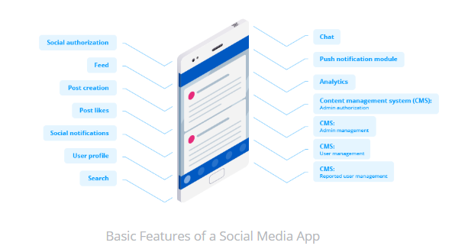

Bibliography

<https://mlsdev.com/blog/how-to-create-social-media-app>

